Our Goals

In order to invest in education, innovation, and infrastructure, the Patrick-Murray Administration proposes to generate new revenue in accordance with these principles:
- Any proposal to generate new revenue must be comprehensive, allowing us to pay our bills, maintain what we have, and invest in new development to foster economic growth.
- Any proposal to generate new revenue must be dedicated, targeted explicitly to specific investments and projects.
- Any proposal to generate new revenue must be competitive and fair, both allowing Massachusetts to compete with our neighbors and protecting the most economically vulnerable among us.

Revenue Proposal
To achieve these goals, the Patrick-Murray Administration proposes the following reforms to our tax system to raise $1.9 B on an annual basis:
- Cutting the sales tax from 6.25 percent to 4.5 percent and dedicating all proceeds to a fund for public works to support transportation, the school building fund, and other infrastructure.
- Increasing the income tax rate by 1 percentage point to 6.25 percent to raise sufficient revenue to support education initiatives. Doubling the personal exemptions so that the increase is fair to all taxpayers, according to their ability to pay.
- Eliminating outdated and overly complicated special favors in the tax code.

Increased Income Tax to Raise Sufficient Revenue for Critical Public Investments

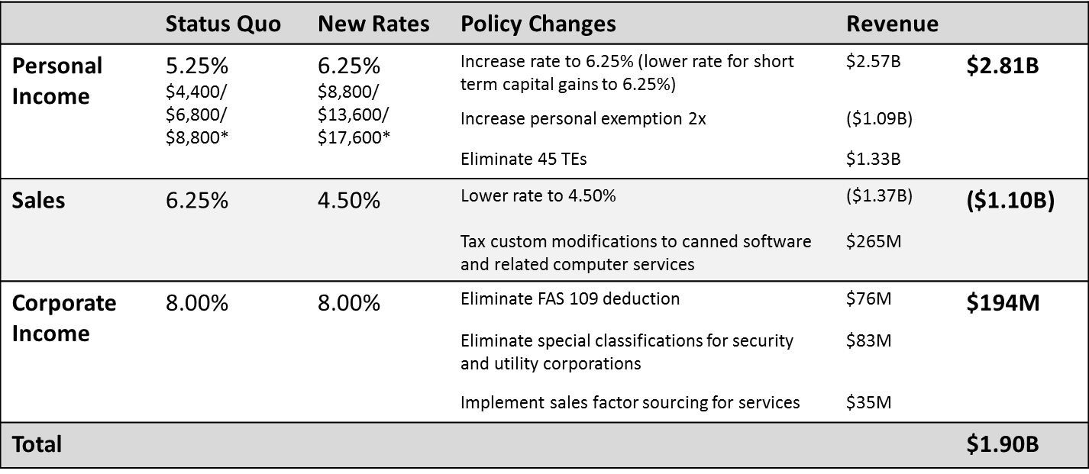We cannot meet the Commonwealth’s needs by cutting deeper or continuing to use one-time resources to fill our revenue gaps. Sustainably financing critical services and investments that are essential to long-term prosperity requires new revenue. We have a generational responsibility to ensure a sustainably financed Commonwealth for our future prosperity.

Economic Competitiveness

The chart below compares the Massachusetts sales tax rate, current and proposed, to that of other states. Our proposed rate reduction would bring Massachusetts from nearly the top to close to the bottom of state sales tax rates, a tax that is widely regarded to be the most regressive tax that states impose. It should also be noted that many other states authorize local jurisdictions (such as counties) to impose sales taxes in addition to the state sales tax which are not reflected in the table below. In Massachusetts, there are no such locally-imposed sales taxes. Further, the corporate excise rate will remain unchanged under this proposal to maintain competitiveness.
Finally, this proposal keeps Massachusetts competitive by ensuring that our total state and local effective tax rate as a percentage of personal income remains similar to the federal average. We will remain at the center of our neighbor and competitor states under this proposal, as shown below.

