­­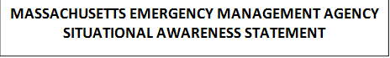

**DATE: January 24, 2015**

**TIME: 9:00 PM**

**SUBJECT: Potentially Major and Destructive Winter Storm/Blizzard to Impact the State**

**Shelter Status:**

Shelters have been or are scheduled to be opened in the following communities:

* Braintree – Independent
* Newburyport (2) – Independent
* Tisbury  - ARC Managed
* Fall River – ARC Supprted
* Falmouth – ARC Supported
* Weymouth – ARC Supported
* Scituate – Independent
* Harwich – ARC Supported
* Brookline – Independent
* New Bedford – Independent
* Eastham – ARC Supported
* Sandwich – ARC Supported
* Yarmouth – ARC Supported
* Barnstable – ARC Supported
* Plymouth – ARC Supported
* Waltham – Independent
* West Newbury – Independent
* Carver – ARC Managed
* Methuen – ARC Managed
* Northampton – ARC Managed

**Storm Reports:**

SKYWARN observers reported the following snowfall totals in Massachusetts as of 8:15 PM:

* Nantucket, MA: 3.5"
* Fairhaven, MA (West Island): 3.5"
* Centerville, MA: 3.5"
* Oak Bluffs, MA: 3.5"
* Freetown, MA: 2.5"
* New Bedford, MA: 2.0"
* Harwich, MA: 2.0"
* Kingston, MA: 2.0"
* Bridgewater, MA: 2.0"
* Taunton, MA: 2.0"

SKYWARN observers reported the following wind gust observations:

Fairhaven, MA:

* West Island: 46 MPH Gust at 800 PM Scituate, MA
* Humarock Beach: 41 MPH Gust at 724 PM; 40 MPH Gust at 634 PM.

**Status Updates:**

MassDOT reports the following:

* Most regional transit authorities have suspended service for Tuesday, January 27.
* The speed limit on the Mass Pike has been lowered to 40 mph between the New York border and Rt. 128. There are currently no restrictions on propane or tandems.
* Rt. 3A is closed in both directions at Rocky Hill Rd. in Plymouth due to multiple spinouts.
* District 1 (Lenox) – Light snow. Roadways are wet and snow covered. The district is chemically treating the roads.
* District 2 (Northampton) – Light snow. Roadways are wet and snow covered. The district is chemically treating the roads.
* District 3 (Worcester) – Light to moderate snow. Roadways are wet and snow covered. The district is chemically treating the roads.
* District 4 (Arlington) – Light to moderate snow. Roadways are wet and slush covered. The district is chemically treating the roads.
* District 5 (Taunton) – Light to moderate snow. Roadways are we and snow covered. Area 5B is reporting icy roads as well. The district is chemically treating the roads.
* District 6 (Boston) – Light snow. Roadways are wet with and snow covered. The district is chemically treating the roads.
* Statewide summary: 1,336 pieces of equipment and 674 MassDOT employees.

MA State Police reports the following:

* All State Police Troop Headquarters report there no significant incidents ongoing at this time.  Troopers are patrolling roadways and responding to minor spin-out type incidents.
* Logan Airport is open.
* In anticipation of significant snowfall and coastal flooding, State Police Marine Unit and State Police Specialty vehicles, supplemented by National Guard assets, are being staged along state highways and coastal communities to facilitate response to storm-impacted areas.

DCR reports the following:

* **Morrissey Blvd will be closed tonight at a time to be determined due to anticipated significant coastal flooding.  Detours will be in place once the road is closed until the storm has subsided.**
* **There will be no parking on ALL DCR roadways and parkways beginning Monday, January 26th, 2015, as of 7:00 P.M. until further notice.  These roads include, but are not limited to: Morrissey Boulevard in Boston, Nantasket Avenue and Hull Shore Drive in Hull, Quincy Shore Drive in Quincy, Winthrop Parkway and Winthrop Shore Drive in Winthrop, and Revere Beach Boulevard in Revere. DCR’s website has a complete list of emergency snow routes.**
* **Due to the blizzard requiring a parking ban on DCR’s Day Blvd. and surrounding city of Boston streets. DCR will accommodate vehicles with valid South Boston resident parking stickers at Castle Island from 6:00 P.M. on Monday, January 26th until 24 hours after the DCR parking ban is lifted.**
* **The Revere Flood Gate at Winthrop Parkway has been closed as of 3:15 PM today until further notice.**
* **DCR managed rinks and park visitor centers were closed as of 7:00 PM today until further notice.**
* **The Melnea A. Cass Recreation Center was closed at 6:00 PM on Monday, January 26, 2015 until further notice.**
* **DCR has been in communication with MassDOT staff and intends to have a conference call tomorrow to more closely coordinate snow removal operations through the duration of the storm.**

Mass 2-1-1 reports the following:

* Since 4:00 PM, Mass 2-1-1 has responded to over 400 storm-related calls.

Utilities Status:

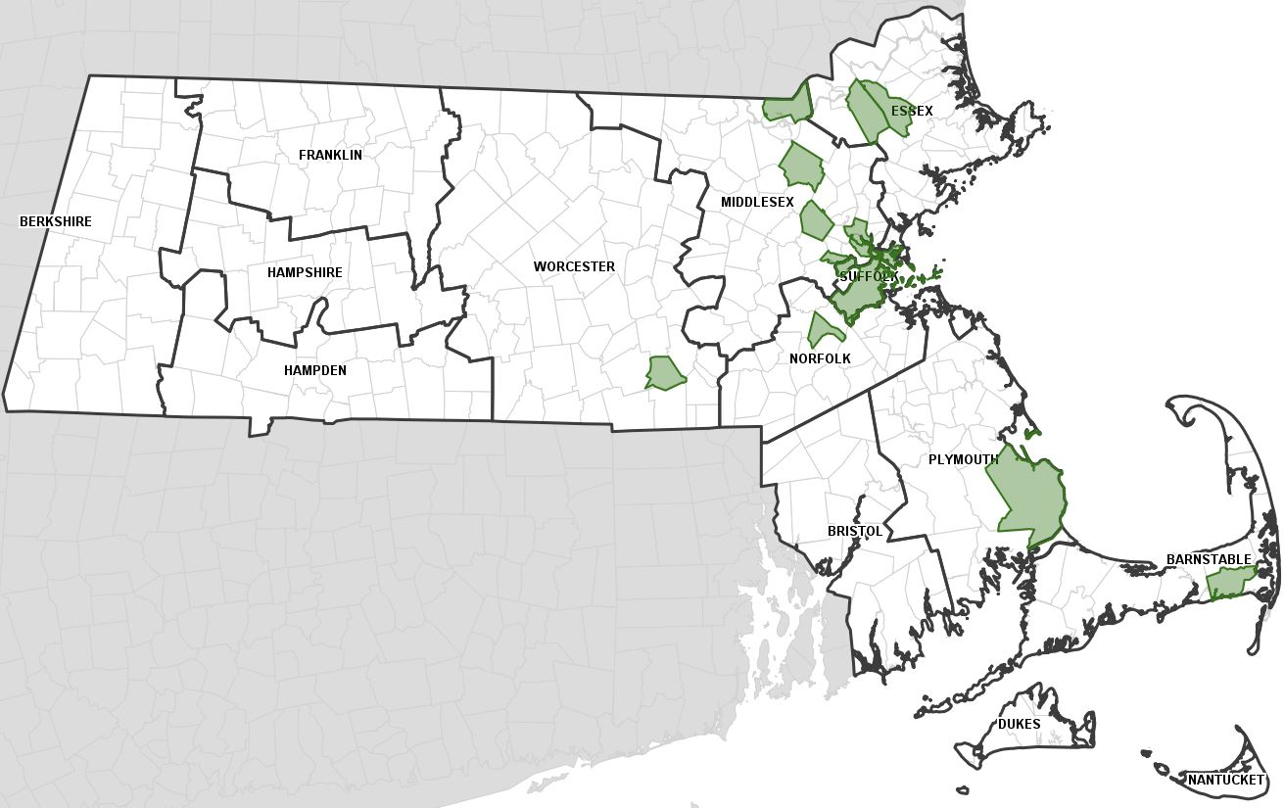

Current power outage numbers by company as of 8:30 PM:

WMECO: 0

National Grid: 47

NSTAR: 440

UNITIL: 0

Total: 487

**MEMA Operations**

The State Emergency Operations Center is operating at Level 3 (Full Activation) as of 4:00 PM this afternoon. Regional EOCs in Tewksbury, Bridgewater, and Agawam are staffed and operational.

The SEOC has stood up its Operations, Planning, Logistics, and Finance Sections and is supported by liaisons from the following Emergency Support Functions (ESFs):

ESF-1 (Transportation)

ESF-2 (Communications)

ESF-3 (Public Works & Engineering)

ESF-4 (Firefighting)

ESF-5 (Business and Industry)

ESF-6 (Mass Care)

ESF-7 (Volunteers and Donations)

ESF-8 (Health and Medical)

ESF-9 (Search and Rescue)

ESF-10 (Hazardous Materials and Environmental Protection)

ESF-12 (Energy)

ESF-13 (Public Safety and Security)

ESF-16 (Military Support)

**Stay Informed**

For additional information and updated forecasts, see [www.weather.gov/boston](http://www.weather.gov/boston) (National Weather Service Taunton) and [www.weather.gov/albany](http://www.weather.gov/albany) (National Weather Service Albany)

Utilize *Massachusetts Alerts* to receive emergency notifications and information from the Massachusetts Emergency Management Agency and the National Weather Service.  *Massachusetts Alerts* is a free app that is available for Android and iPhones. To learn more about *Massachusetts Alerts*, and for information on how to download the free app onto your smartphone, visit: [www.mass.gov/mema/mobileapp](http://www.mass.gov/mema/mobileapp).

Utilize MEMA’s real-time power outage viewer to stay informed about current power outages in your community and region, and across the state, including information from utility companies about restoration times: <http://mema.mapsonline.net/public.html>

**Online Resources:**

For additional information and resources, visit:  
Massachusetts Emergency Management Agency at [www.mass.gov/mema](http://www.mass.gov/mema)  
MEMA's Facebook page: <http://www.facebook.com/MassachusettsEMA>  
MEMA Twitter: [@](http://twitter.com/massema)MassEMA  
Federal Emergency Management Agency at [www.fema.gov](http://www.fema.gov)  
National Weather Service/Taunton at [www.weather.gov/boston](http://www.weather.gov/boston)  
National Weather Service/Albany, NY at [www.weather.gov/albany](http://www.weather.gov/albany)  
National Weather Service Weather Prediction Center: <http://www.hpc.ncep.noaa.gov/>  
National Weather Service Storm Prediction Center:  <http://www.spc.noaa.gov/>  
Northeast River Forecast Center: <http://www.weather.gov/nerfc/>

Mass211 at [www.mass211.org](http://www.mass211.org/)