TWO WEEK LOOK-AHEAD
Watertown Riverfront Park and
Braille Trail Project
October 27, 2014 – November 7, 2014

The following are activities you can expect to see over the next two weeks for the Waterfront Riverfront Park and Braille Trail Project:

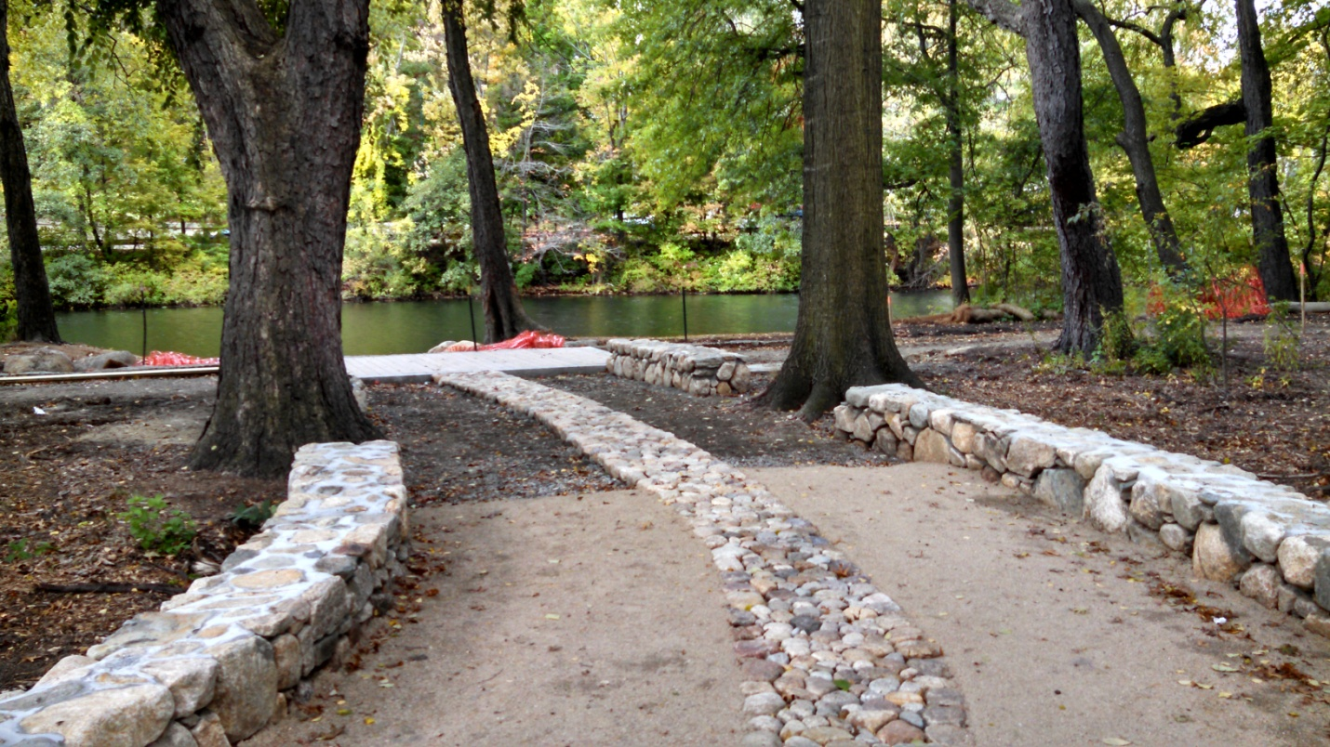
- In sensory garden; complete bottoms on mishoon boats, install marimba bench, and install sensory garden benches.
- Install new base for relocated street light at Irving Street entrance
- Commence electrical work
- Install benches on overlook deck
- Complete picnic tables installation

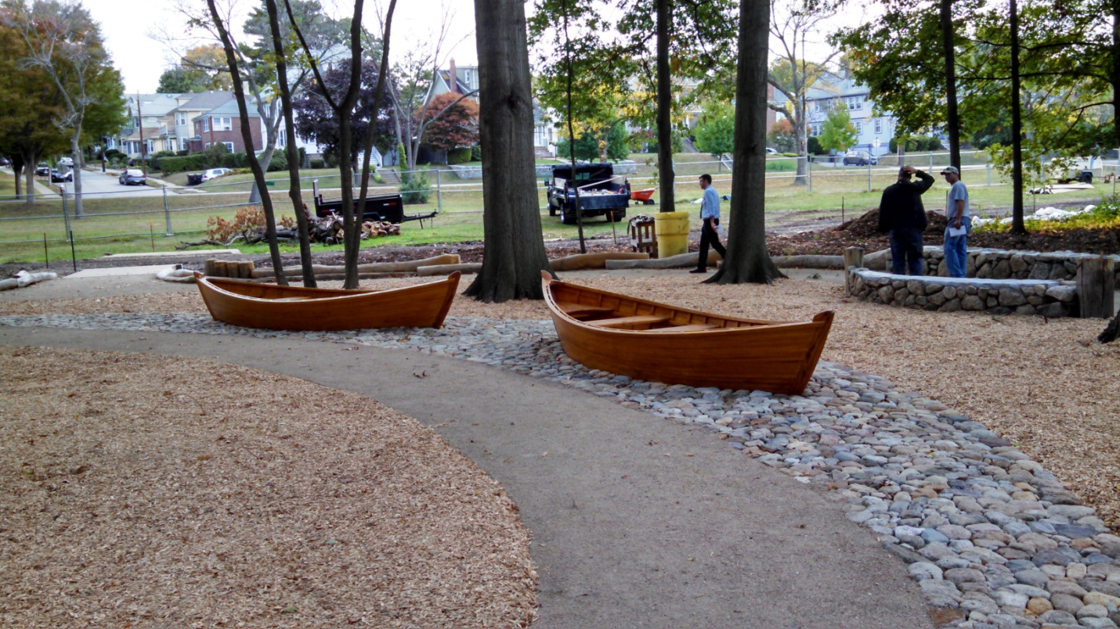
Construction Work Schedule:
Sensory Garden under construction
Monday-Thursday, 7AM
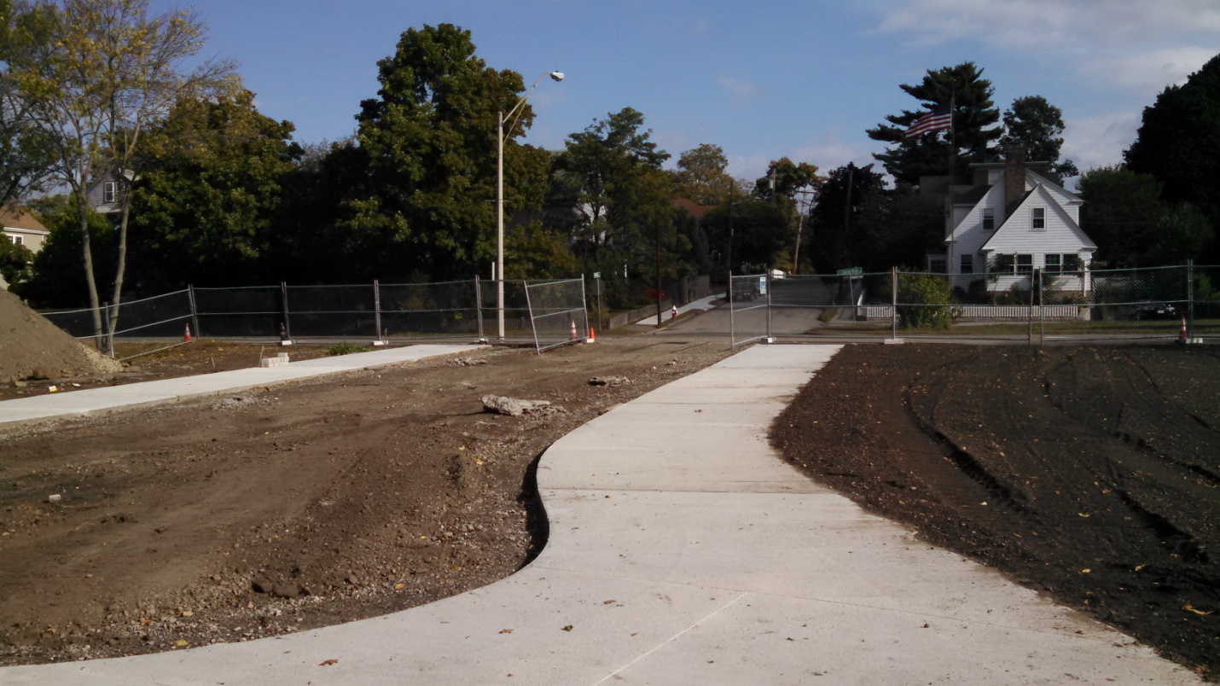
to 6:00PM.

Public Access: The
Secondary path along the Charles River is closed for
the duration of the
Mishoon Boats installed
construction project.

Pedestrians can use the sidewalk directly adjacent to Charles
View from riverbank to Irving Street entrance
River Road, and cyclists can use the freshly painted bike lanes
on Charles River Road.

Questions or concerns about the project should be directed during regular business hours to either DCR Resident Engineer Jay Yuan at (617)212-7359, or DCR Project Manager Rick Corsi at (617) 626-1431.

Join us on Twitter @MassDCR - Visit http://mass.gov/dcr

